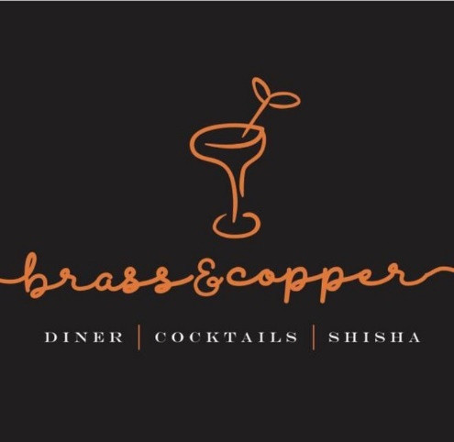

Job Description

Thank you for your interest in working with Brass & Copper!

We are passionate about our people; they are the bedrock of our business, which is why we invest time and effort in recruiting the perfect match! Our employees are passionate about Brass & Copper, their role and the overall success of the company. We are all motivated to drive our own success and achieve individual objectives. Communication is key to any role here as our employees continually build relationships with our customers and at all levels across the business.

We’re fast paced, so all employees need to able to adapt to change quickly, be enthused and excited about what’s around the corner for us.

Job Title: Hostess

Role: Full-time

Location: 1 Olubunmi Owa, Lekki Phase 1, Lagos.

Start date: As soon as possible

Role background:

As a Hostess at Brass & Copper you will be a vital part of the guest experience. You will welcome all guests in a warm and friendly, yet professional manner and you must be passionate about delivering an exceptional and genuine service.

Role functions:

- Delivering excellent customer service to all customers
- Meeting and greeting customers
- Assigning a suitable table for customer needs upon arrival
- Ensuring the general area is tidy and well-organised at all times
- Having knowledge of the restaurant menu and beverage list
- Providing general administration duties as answering telephone and dealing with booking and general queries
- Assisting the team with various tasks as required
Key Skills and Requirements:

- A high standard of personal presentation and appearance
- Proven Hostess experience in a busy and high-volume restaurant.
- Possess ability to multi-task
- A good command of both written and spoken English
- Excellent communication skills
- Excellent telephone manner; articulate and friendly
- Excellent guest service skills
- Ability to work under pressure
- Attention to detail
- Confident, professional and welcoming personality

The ideal candidate:

- Someone who is friendly and welcoming
- Someone who can build rapport quickly with others
- Someone who is level-headed and efficient
- Someone who is willing to go the extra mile
- Someone who takes a professional and committed approach to work

All interested individuals must send a cover letter to GoodHair@rensan.co.uk, detailing why they should get the job and what they believe they can add to the business. Attach your CV and ensure you use subject title ‘Brass & Copper Hostess’.

Failure to apply in the way we have specified will disqualify you immediately, please ensure that you read thoroughly. Please also note that if your application is successful we will contact you.

