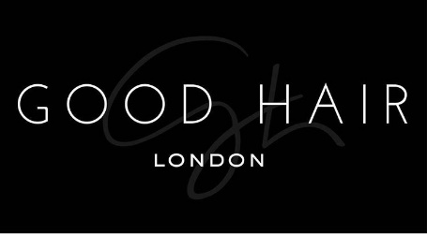

Job Description

Thank you for your interest in working with Good Hair!

We are passionate about our people; they are the bedrock of our business, which is why we invest time and effort in recruiting the perfect match! Our employees are passionate about Good Hair, their role and the overall success of the company. We are all motivated to drive our own success and achieve individual objectives. Communication is key to any role here as our employees continually build relationships with our customers and at all levels across the business.

We’re fast paced, so all employees need to able to adapt to change quickly, be enthused and excited about what’s around the corner for us.

Job Title: Administrative Manager

Role: Full-time

Location: 1 Olubunmi Owa, Lekki Phase 1, Lagos.

Start date: As soon as possible

Role background:

This role spans across HR, Finance and general management duties. The purpose of this position is to support the daily operations within Good hair by planning and supervising the most effective and efficient administrative procedures. This will cover the hiring and training of staff, office supply management, and day-to-day operations.

Role functions:

- Managing the recruitment process in-house and in partnership with our external agencies
- Overseeing the training of new staff
- Overseeing career progression and employee reviews on a regular basis
- Ensure the smooth and adequate flow of information within the company to facilitate other business operations
- Manage schedules and deadlines
- Organize and supervise other office activities and events
- Managing the monitoring and provision of office supplies as needed
- Improving and streamlining operations and procedures.

Key Skills and Requirements:

- Proven experience as administration manager
- In-depth understanding of office management procedures, legal policies and health codes
- Familiarity with financial management
- Proficient in Microsoft Office programs
- Excellent organizational and multitasking abilities
- A team player with leadership skills
- BSc/BA in business administration or relative field
- Proficient in Microsoft Office Suite
- Knowledge of customer service practices
- Project management experience
- Experience supervising others
- Budgeting and financial reporting experience

The ideal candidate:

- Someone who is level headed and a critical thinker
- Someone who likes to help others excel
- Someone who is confident in making decisions
- Someone who takes a professional and committed approach to work
- Someone who gets involved and contributes with feedback and ideas to continuously improve Good Hair
- Someone with an analytical mind and problem-solving skills.

All interested individuals must send a cover letter to GoodHair@rensan.co.uk, detailing why they should get the job and what they believe they can add to the business. Attach your CV and ensure you use subject title ‘Good Hair Admin Manager’.

Failure to apply in the way we have specified will disqualify you immediately, please ensure that you read thoroughly. Please also note that if your application is successful we will contact you.

