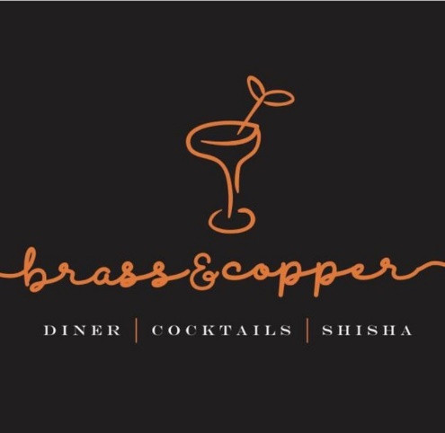

Job Description

Thank you for your interest in working with Brass & Copper!

We are passionate about our people; they are the bedrock of our business, which is why we invest time and effort in recruiting the perfect match! Our employees are passionate about Brass & Copper, their role and the overall success of the company. We are all motivated to drive our own success and achieve individual objectives. Communication is key to any role here as our employees continually build relationships with our customers and at all levels across the business.

We’re fast paced, so all employees need to able to adapt to change quickly, be enthused and excited about what’s around the corner for us.

Job Title: Waiter / Waitress

Role: Full-time

Location: 1 Olubunmi Owa, Lekki Phase 1, Lagos.

Start date: As soon as possible

Role background:

We are looking for a well-qualified, highly skilled and experienced Waiter or Waitress to take orders and deliver food and drinks to our esteemed customers.

Our ideal candidate will add to the dining experience for customers. We are looking for someone who will have the personality, attitude and patience to thrive in this role.

Role functions:

- Greet and escort customers to their tables
- Serving customers
- Providing detailed information on menus and recommendations upon request
- Preparing tables by setting up linens, silverware and glasses
- Taking accurate food and drinks orders
- Communicating order details to the Kitchen Staff
- Providing the bill and collecting payment
- Checking dishes and kitchenware for cleanliness and presentation
- Providing excellent customer service to guests

Key Skills and Requirements:

- A high standard of personal presentation and appearance
- Proven Waiting experience in a busy and high-volume restaurant.
- Possess ability to multi-task
- A good command of both written and spoken English
- Excellent communication skills
- Excellent guest service skills
- Ability to work under pressure
- Attention to detail
- Confident, professional and welcoming personality
- Flexibility to work in shifts

The ideal candidate:

- Someone who is friendly and welcoming
- Someone who is attentive and patient
- Someone who is level-headed and efficient
- Someone who is willing to go the extra mile
- Someone who is a team player
- Someone who takes a professional and committed approach to work

All interested individuals must send a cover letter to GoodHair@rensan.co.uk, detailing why they should get the job and what they believe they can add to the business. Attach your CV and ensure you use subject title ‘Brass & Copper Wait staff’.

Failure to apply in the way we have specified will disqualify you immediately, please ensure that you read thoroughly. Please also note that if your application is successful we will contact you.

